**Yuekuan ZHOU**

Assistant Professor of Sustainable Energy and Environment Thrust, Function Hub, HKUST(GZ)

Affiliate Assistant Professor of Mechanical and Aerospace Engineering, School of Engineering, HKUST



**Research Interests**

* Low-carbon and zero-carbon buildings
* Artificial intelligence for dynamic performance prediction and optimization
* Interactive energy sharing network with buildings, electric vehicles, fuel cell electric vehicles
* Renewable energy, energy conversion and management strategies
* Carbon footprint and lifecycle carbon emission of buildings
* Passive and active energy-efficient technologies in buildings

**Biography**

Prof. Yuekuan ZHOU is an Assistant Professor of Sustainable Energy and Environment Thrust, Function Hub at HKUST(GZ). He is also an Affiliate Assistant Professor of Mechanical and Aerospace Engineering, School of Engineering, HKUST. He received his PhD degree from Hong Kong Polytechnic University (HKPolyU), Master’s degree from Hunan University and Bachelor from PLA university of Science and Technology. His research works have been published in top peer-reviewed journals and conferences, including Renewable & Sustainable Energy Reviews, Applied Energy, Energy Conversion and Management. He was awarded the Best Paper Award in CUE2020: Applied Energy Symposium: Low carbon cities and urban energy systems, organized by Applied Energy journal. He is currently serving as an editor to launch a new international book: Advances in Digitalization and Machine Learning for Integrated Building-Transportation Energy Systems (in progress, Elsevier). He also serves as an editorial board member for several international journals, like Energy Nexus (Elsevier). Dr. Zhou has also been invited as guest editor to launch several special issues in SCI journals.

**被动式绿色建筑跨尺度模拟平台与优化**

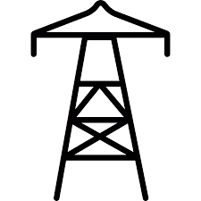

**G2B/B2G**

**V2G**

**B2V/V2B**

**V2G**

**G2B/B2G**

**B2V/V2B**

**… …**

**V2G**

**V2G**

**B2V/V2B**

**B2V/V2B**

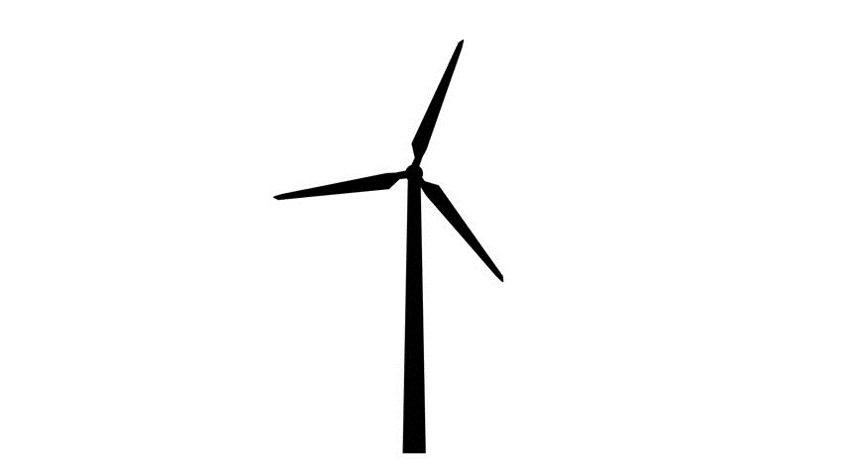

建筑光伏一体化

**V2G**

建筑光伏一体化

办公建筑

酒店建筑

商业建筑

居住建筑

屋顶光伏



电网



电网

**G2B/B2G**

**G2B/B2G**

**G2B/B2G**

建筑光伏一体化

建筑光伏

建筑光伏

建筑光伏

建筑光伏

屋顶光伏

屋顶光伏

屋顶光伏

屋顶光伏



**多能源社区规划与零碳平台**